Datasets

1. Race/sex population in each county (1990-2020)

* 1990-1999 <https://library.duke.edu/data/sources/popest>
* 2000-2010 <https://library.duke.edu/data/sources/popest>
* 2010-2020 <https://www.census.gov/programs-surveys/popest/technical-documentation/research/evaluation-estimates/2020-evaluation-estimates/2010s-county-detail.html>

(Bottom-most “United States” dataset link)

Variable descriptors 1990-1999 and 2000-2010

<https://repository.duke.edu/catalog/fbe3aba5-1aa5-4814-9cd2-eccfacbc498d>

Variable descriptors 2010-2020

<https://www2.census.gov/programs-surveys/popest/technical-documentation/file-layouts/2010-2020/cc-est2020-alldata6.pdf>

1. Unemployment rate statistics in each county (1990-2020)

National Unemployment rate each year (1990-2020)

<https://www.bls.gov/cps/tables.htm#empstat>

(County level) Bureau of Labor Statistics (all tables with same format, save xls as csv)

<https://www.bls.gov/lau/>

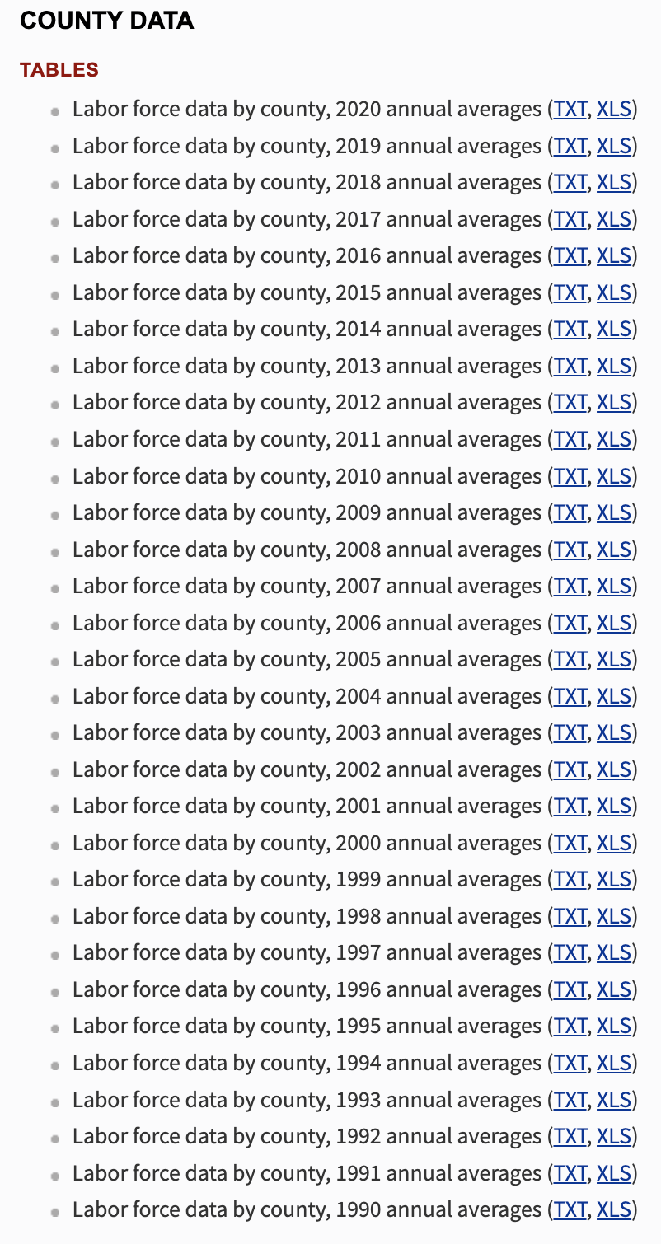

1. Age group datasets

2010-2020 age dists (1st "United States" file)

<https://www.census.gov/programs-surveys/popest/technical-documentation/research/evaluation-estimates/2020-evaluation-estimates/2010s-county-detail.html>

2000-2010 age dists (at bottom have to download each state seperately)

<https://www.census.gov/data/datasets/time-series/demo/popest/intercensal-2000-2010-counties.html>

1990-1999 age dists (at bottom have to download each year seperately) txt files open in xcel the save as csv

<https://www.census.gov/data/datasets/time-series/demo/popest/intercensal-1990-2000-state-and-county-characteristics.html>

1. Educational attainment

<https://www.ers.usda.gov/data-products/county-level-data-sets/download-data/>

1. Election data from CQ Press Library (Accessed with UCI library)

(UCI Library subscription cancelled?)

1. Polling data from
2. FiveThirtyEight

<https://github.com/fivethirtyeight/data/tree/master/polls>

1. Senate AND governor polling data from
2. Roper Center for Public Opinion Research

<https://ropercenter.cornell.edu/ipoll/study/31116394>

<https://ropercenter.cornell.edu/ipoll/study/31115091>

1. National GDP growth rate scraped from table at

<https://www.macrotrends.net/countries/USA/united-states/gdp-growth-rate>